# Features

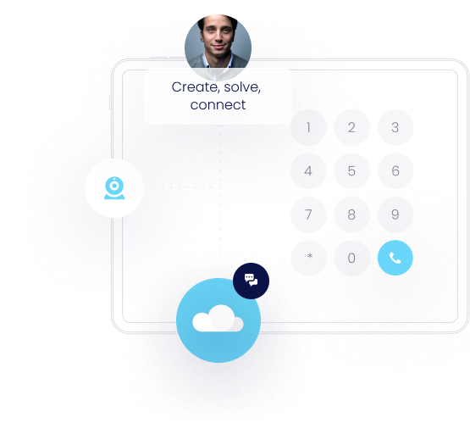

## Low-Code Flow Editor

Get access to an all-in-one flow editor that allows you to create highly customizable workflows for calls, fax, and IM. Our flow editor can be used to generate any calling workflow imaginable.

[Create account](https://app.lineblocs.com/#/register)

## DID number portal

Purchase numbers from a DID inventory that includes local, toll free, and vanity-based numbers. We also offer a full range of DIDs that span across multiple rate centers throughout North America.

[Create account](https://app.lineblocs.com/#/register)

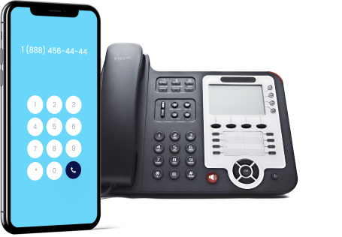

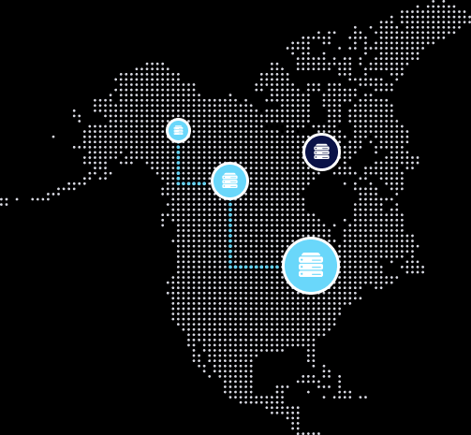

## PoPs and high availability

Our network allows you to provision extensions nearest to your location and rotates from more than 10+ PoPs across North America.

[Create account](https://app.lineblocs.com/#/register)

## Overcome Challenges with existing on-premise calling solutions

Designed using the best technologies, Lineblocs offers features that can help you create a calling, fax, and IM environment that can easily scale.

[Create account](https://app.lineblocs.com/#/register)







## An Overview

IMG_262

### High Availability

Our network is made up of best practices and created using secure technologies.

IMG_263

### Number Inventory

Self-serve number rental and management in one easy to use number management portal.

IMG_264

### Scalable Services

Our cloud network is built with scale in mind – all of it – including our software, user portals, and network.

IMG_265

### Low-Code

Our solutions are entirely based on low-code integrations, allowing teams to create high-level workflows.

## Learn More

Have queries regarding our offerings? Feel free to contact us.

窗体顶端

窗体底端